Call for concept notes
Rule of law programme Fund – Indonesia
23/04/2015

The Embassy of the Kingdom of the Netherlands in Jakarta has established a Rule of Law Fund for the purpose of enhancing synergy and cooperation within the law and justice sector in Indonesia, as well as to promote the regional legal order. The Rule of Law Fund builds upon the recommendations of the 2012 Dutch evaluation of its bilateral rule of law program in Indonesia and is in alignment with the strategic goals outlined in the Joint Declaration on a Comprehensive Partnership between Indonesia and the Netherlands as well as the Embassy’s 2014-2017 Multi Annual Strategic Plan.

The International Development Law Organization (IDLO) is responsible for the management of the Rule of Law Fund and awarding grants that will contribute to the provision of technical assistance, mobilisation of experts, and strengthening of capacity in four focus areas:
- Capacity building of legal institutions
- Legal service delivery, focusing on legal aid, access to justice and accountability
- Research activities in support of the above and in relation with security, rule of law and human rights
- Strengthening the regional legal order in cooperation with Indonesia within the framework of ASEAN

The Indonesia Netherlands Legal Update (INLU) which took place in November 2014 in The Hague, was a unique opportunity for Dutch and Indonesian counterparts to meet and discuss recent progress in legal cooperation and identify priority areas for future work. The rule of law fund will be a key instrument to support some of the priorities identified during these discussions and provide financial support to translate them into concrete activities and projects.

In advance of the INLU follow-up meeting which will be organised in Jakarta on June 4, 2015, IDLO is launching a call for expressions of interest to implement programs under the framework of the Rule of Law Fund. The initial call for proposals is to generate programmatic ideas for discussion with Indonesian authorities and could lead to the development of cooperation projects or pilot activities. Organizations who wish to apply are invited to use the standard concept note form in accordance with the rules set out in this notice.

Concept notes to be sent by email at the following address: IDLO-ID-Tender@idlo.int

Deadline: 26 May 2015

For any inquiries, contact: IDLO-ID@idlo.int,
- Type of candidates
Candidates can be NGOs, intergovernmental organizations, associations, foundations, civil society groups, networks, consortiums and academic institutions. Government agencies cannot receive funds directly but can also submit applications. In that case, funds will be managed by a third party and implemented in close cooperation with the government agency. Candidates must be legally registered in Indonesia and can submit a maximum of two concept notes.

- Duration
The duration of the proposed intervention should be for a maximum of 12 months. While the Rule of Law Fund is a three-year program, this first round of program ideas will be limited to one year. Candidates can submit short term activities or use the funds as seed funding for longer term activities to be implemented in several phases. Subsequent phases and follow-up activities will potentially be covered in the next round of applications.

- Budget
The maximum budget for a proposed intervention is: EUR200,000.

- Type of activities
The activities to be funded by the Rule of Law Fund should be related to the four focus areas. Some of the interventions that could be covered are (non-exhaustive list):
- development of capacity building programs for rule of law actors, focusing on strengthening institutions and building new skills to improve the quality of justice;
- identification of opportunities for cooperation between Indonesian and Dutch rule of law actors, that fall within the framework of existing partnerships and MoUs;
- promotion of access to justice for women and vulnerable groups;
- development of anti-corruption programs;
- development of alternative dispute resolution mechanisms;
- development of programs to integrate legal aid and legal education services to reinforce the capacity of marginalized groups;
- development of projects to scale up current access to justice pilot projects;
- setting up of peer-to-peer activities to ensure knowledge sharing;
- undertaking of participatory action research;
- development of innovative pilots and novel approaches to improve Rule of Law;
- support the establishment of the ASEAN Economic Community.

- Contracting authority
IDLO - International Development Law Organisation - http://www.idlo.int
title of the project
Concept Note to the International Development Law Organization
Date xx/MONTH/201x

Maximum 5 pages + 1 page for logframe

1. CONTEXT AND PROBLEM STATEMENT (max. 1 page)
Provide an analysis of the problems and needs that will be addressed by the Project. Clearly state the present situation at the national and local levels where the Project will be implemented, including data when possible. Briefly explain how the Project will relate to actions, plans and/or programs that have been or are being undertaken in the same area – particularly to avoid duplication and identify potential synergies.

2. DESCRIPTION OF THE PROJECT (max. 1 page)
Provide a description explaining the relevance of the Project and how it will address the problems and needs identified in the previous Section. The description should include and elaborate on the Project’s overall impact/outcome(s). Provide detailed description of the output(s) of the Project and the activities to be undertaken to meet the proposed outcome(s).
Please summarize them in the annexed logic model.

3. BENEFICIARIES (max. 1/5 page)
Provide a description of the final beneficiary(ies) of the Project by identifying their needs and constraints and demonstrating the relevance of the proposed Project to address them. Also indicate in which provinces the project will be implemented.

4. IMPLEMENTING AGENCY(IES) (max. 1/5 Page)
Provide an overall description of the Implementing Partner(s), including comparative advantages.

5. DURATION (max. 1/3 page)
Estimate the duration of the Project by taking into consideration all relevant factors that might affect its implementation. Indicate if this is a short project or if subsequent phases could be planned to complement this initial phase.

6. RISKS ANALYSIS (max. 1/3 page)
Provide a general description of the main preconditions and assumptions for the successful implementation of the Project. In addition, identify the main risks for the Project and suggest mitigation measures.

6. MONITORING AND EVALUATION (max. 1/3 page)
Provide an explanation on how performance will be monitored and evaluated to ensure that activities are delivered within timelines and results are producing positive impact.

7. SUSTAINABILITY (max. 1/5 page)
Provide an explanation on how the impact of the Project will be made sustainable after completion. If applicable, describe the possibilities for replication and extension of the outcomes of the Project, including follow-up activities, strategies, ownership, advocacy, etc.

7. BUDGET
The estimated overall cost for the Project, by outcome /output.

Outcome/output | Estimated cost
Outcome 1
Output 1.1
Output 1.2
…
TOTAL

CONTACTS
Provide the contact details of the Implementing Partner’s focal points for the proposed Project.
Organization name
Full address
Email
Fax
Phone number
Contact Person (name/title)

Annex 1: Logic model (suggested format to be adapted to the project scope)
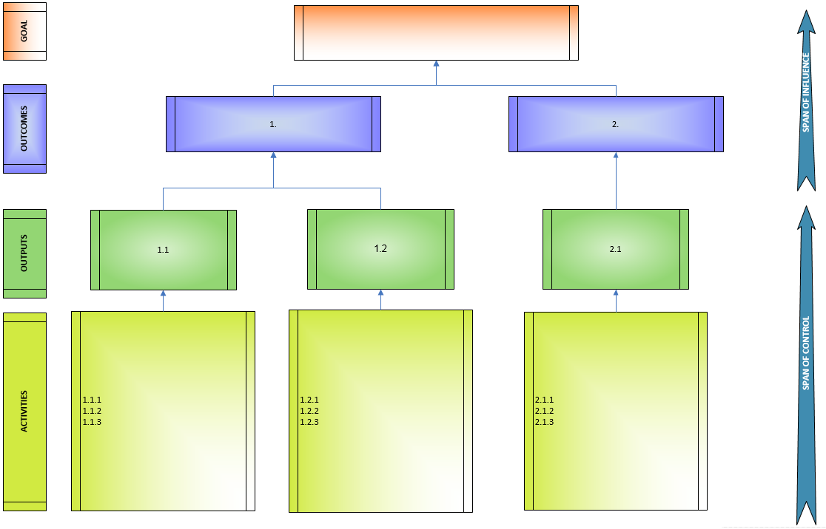
Goal
The overall impact of the Project.

Outcomes
The immediate development outcome/impact on the Project area or target beneficiary, i.e. the change or benefit that will be achieved by the Project.

Outputs
Provide a bullet-point list of the specific deliverables/results the Project will produce.

Activities
The key activities that will be undertaken to produce each of the specific deliverables/results and how they will support achievement of the purpose.

