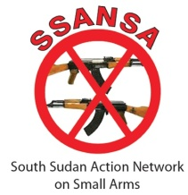

CIMIC LAUNCH CONFERENCE
“SECURITY IS EVERYONE’S BUSINESS”
Improving State – Civil Society Relations for enhanced Community Security
February 28, 2013| Bor – Jonglei State | South Sudan

Summary Report

The conference “Security is everyone’s business; Improving State – Civil Society relations for enhanced community security” was held on February 28 in Jonglei State’s capital Bor at the Garden Resort Hotel. The conference was organized by South Sudan Action Network on Small Arms (SSANSA) as part its initiative to enable better civilian protection policies and practices through regular information sharing between providers and recipients of protection. The rationale for the initiative is the fact that, as victims of various forms of violence and the hosts to criminals, communities can best articulate the extent of their insecurities and provides the contextually appropriate suggestions of protection mechanisms. SSANSA’s conviction is that a dialogue between the protectors and the protected is indispensible to providing the appropriate and adequate form of protection to civilians.
The conference was attended by fifty participants drawn state institutions and civil society sectors. Representatives of state government institutions including county commissioners, County Executive Directors, Police Services, Bureau of community security and small arms control, County peace desk representatives. Civil society representatives included Paramount Chiefs, youth and women representatives, and civil society organizations. The meeting was also attended by a representative of IKV Pax Christi which jointly supported the initiative with Cordaid. UNMISS which is an intergovernmental organization with a mandate to provide protection for civilians and works in broader aspects of security and justice was also represented.
The conference provided a platform for an open dialogue for protection stakeholders to discuss critical security issues. It did not just highlight contemporary security concerns but discussed the role[s] each stakeholder should play in enhancing community security at the local level.
The conference was addressed by H.E. the Governor of Jonglei State – who officially opened the conference, the State Minister of Local Government and the Chairperson of SSANSA who gave a keynote address. All the speakers who made the opening remarks underscored the significance of joint action in addressing the challenges of insecurity in Jonglei state.
Keynote address, Rev. James, SSANSA Chairperson
In his keynote address, Rev. James highlighted the rationale behind the initiative, which is giving civilians the opportunity to shape the agenda for their protection.
..“The SSPS and the SPLA cannot provide citizens just any form of protection. They should provide the appropriate form of protection that citizens need. And these needs can best be defined and articulated by the citizens themselves. Nobody knows the security threats of the Bor Community better than the citizens of Bor themselves, The same thing with Akobo, Same applies Pibor, Uror and the rest of the counties of Jonglei. And the citizens can suggest the best solutions to their security challenges.”
Rev. James further stressed that, while the challenges of insecurity in Jonglei are easily seen from its manifestations, the root causes are deep rooted and often mechanisms to address insecurities target the manifestations rather than the root causes. He emphasized that without a holistic approach to community security, development would remain a dream. He further explained that development is one factor that could lead to security.
“We the communities cannot be fighting each other and making our communities unsafe for both ourselves and our neighbors – simply because there is no development. Meanwhile, the government also cannot just sit and fold hands and say; insecurity is too high in the state, so we cannot bring development to the state. We need to join hands to pursue these two fronts simultaneously. But we can only do it if we all recognize that it is our mutual responsibility.” Rev. James
Official Opening Speech By H.E Kuol Manyany, Governor Jonglei state
The Governor concurred with the theme of the conference and applauded the security dialogue initiative. He said that; the conference should mark the beginning of a journey towards ending insecurity and achieving sustainable peace and harmony as well as co-existence among the communities in Jonglei state.
..“Having in mind the importance of peace and stability, I completely agree with the theme of this workshop, security is everyone’s business. We need a secure environment for business to flourish. And also for development and investment to pick up. This is what makes the workshop a special one.” H.E, The governor of Jonglei state, H.E Kuol Manyang
The governor also agreed with point on the correlation between security and development as highlighted by the Chair person of SSANSA. He emphasized that security is needed in the state to enable investors come and help in development. They attributed lack of effective delivery of services such as; limited health facilities, education, roads and bridges to the on-going insecurity in the state caused by rebel groups and other illegal guns holders.
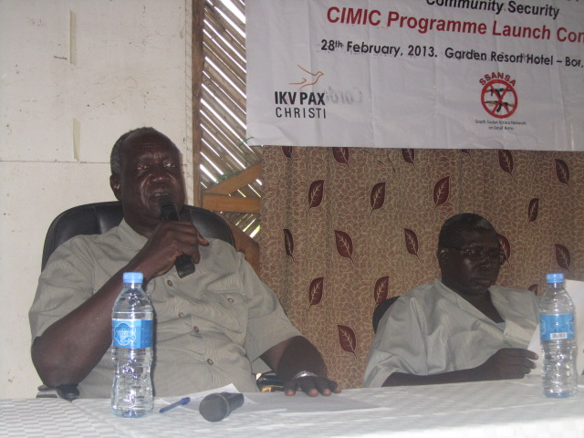
“The investors who have money… cannot come because they see that we are killing ourselves, they may be killed. They are fearing to come” Said the Governor.
He encouraged the organizers of the initiative to roll out of this program to the counties, noting that the counties are the most affected by insecurity - and that it would also be much easier to conduct the meetings because most of the counties are mono lingual communities. Underscoring the challenges posed by the gun misuse to socio-economic progress in the state, the governor urged the participants to seek answers to the question – “why people acquire guns?”
H.E Kuol Manyang Juuk – The Governor of Jonglei State

..“You talk about small arms, did the small arms come by themselves to the hands of our people or did our people go to look for arms. And why do they have to arm themselves. And why do they use them against their fellow citizens?” by understanding this phenomenon, you will be more likely to generate workable approaches to address this national concern and the challenges involved. Said the Governor
He urged the participants to look beyond the usually quick conclusion that the conflicts causing pervasive insecurity in Jonglei are tribal conflicts – and to instead critically analyze the trends of the conflicts in Jonglei vis-a-vis those of other states. Among the factors to consider is the nature of livelihood, which is mainly pastoralist in Jonglei State and agro-based in others in neighboring Central and Eastern Equatoria state. He stressed that the conflicts in the state have more to do with ‘the cow’ other than the tribal differences. He asked the participants to generate ideas that will restore respect to the value of human life, peace and stability.
“If it is tribal, In Bor here there are various tribes but why are there no such conflicts?” Mr. Governor asked.
The minister of Local government further backed up the need – stressed by the governor – to roll the initiative to the county levels.
“In bor town, there is no problem of insecurity; the problems are in the county. We invite you to go to the counties and meet with all the stakeholders of security in the counties” Jonglei State Minister of Local Government, Hon. Ding
The governor informed the participants that the state government is in the process of forming community police to complement efforts of the regular state police in maintaining security. He urged the communities to cooperate with the police by providing relevant information associated to insecurity, feed these police and construct local posts for them.
The minister of Local government highlighted some of the initiatives of the government has put in combating insecurity and build peace in the state. Among these efforts were;
- Adoption of the Jonglei State Small Arms and Ammunitions Bill, which empowers county commissioners to arrest and prosecute anyone in possession of illegal arms. That this piece of legislation places a one year non – bail sentence on any civilian caught in possession of illegal firearms.
- Establishment of peace desks to support county authorities in efforts geared towards enabling peaceful resolution of disputes without resorting to gun violence.
- Ongoing state-wide civilian disarmament campaign.
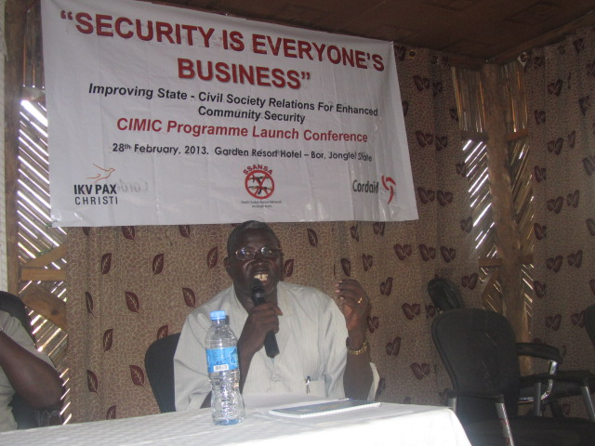
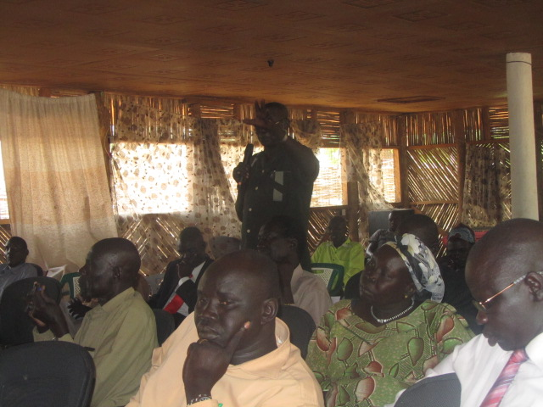
Minister of local government, Jonglei State
Minister of Local Government, Hon. Ding Participants listening during the meeting

Emerging Issues
After the official opening, participants from the civil society side were given the opportunity to raise their critical security concerns. They were asked to seek out for the actors responsible for the challenges as they identify the main security concerns and what they can do to address the security problems they identified. Participants came up with myriad issues, which included the following:
Concerns about rebels loyal to David Yau Yau
The security issue that came up and almost dominated the discussions was the issue of rebels loyal to David Yau Yau. Communities felt that the government should explain to them, why Yau Yau is targeting innocent local civilians in the rural areas and instead of the army or urban areas like Bor and Juba. While they acknowledged that Yau Yau’s issue falls within the mandate of the high political leadership and the army at both National and States governments, they stressed that they (communities) need to know the commitment of government in ending the conflict. They expressed their frustration noting that if the government does not take immediate measures against Yau Yau, they the innocent local civilians will continue to be victims to Yau Yau’s forces.
“You the government take care of Yau Yau if he is your person. If not , give us weapons to face him. If you don’t give us weapons, where Yau Yau gets his weapons, we shall also go and get weapons from there.”
Paramount Chief

Civilian Disarmament and Insecurity

Persistent attacks – manifesting mainly inform of cattle rustling – by the youth who evaded the ongoing statewide civilian disarmament emerged as a critical security issue. While many participants commended the disarmament they stated that their lives and livelihood are under severe threats due to the vulnerability caused by the exercise. Participants strongly asserted that the disarmament carried in the state was not comprehensive some communities have been left out from the exercise. However, a number of participants indicated that some members of the regular forces – who are involved in the disarmament exercise – are themselves perpetuators of cattle rustling. While some participants called for forceful disarmament of remaining members of communities who did not disarm, others felt that those communities who have been disarmed should be given guns so they could protect their own people.

“Everyone must be forcefully disarmed. The government should provide security without excuse.” Youth Representative
As core issue of the conference, participants widely recognized the need for information sharing and thus embraced the idea of community meetings on security, however, kept raising previous appeals that the initiative is rolled to the county levels because they are the ones most affected by insecurity.
The chiefs recognized that information sharing could enhance both rapid response and give way to justice, however pointed out that they (chiefs) mostly do not share critical criminal information due to the fear that it would put their lives at risks because the criminals are also members of the communities – and they have guns. That it is necessary for the whole community to unite for the cause of community security and justice.
Insecurity and the Justice system
Both civil society and representative of the government saw weak justice system as an obstacle to community security – although they look at it from different angles. Participants from the civil society side indicated that the justice system is tainted with tribalism and corruption. When prospects for justice becomes thin and thinner, citizens often resort to their own dispute resolution means, often involving use of small arms. This highlights how initiatives to improve security should be connected with improving justice sector.

“We are very tribal that things seems like we are not even a county. If a criminal is jailed today, they are unlocked the next day as long as they know some tribes-mate in the system. The law exists but it is not implemented.” Youth Representative
Insecurity and Gender
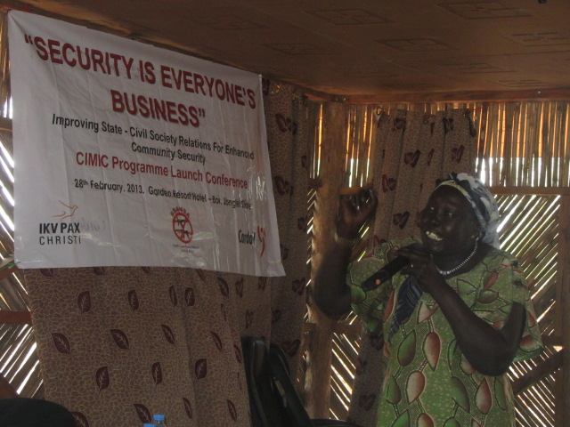
The women expressed their bitterness against the men on the destruction gun violence is causing to them as women in Jonglei State. Emphasizing that, men are the sole perpetuators in the on-going conflicts and gun violence in Jonglei state. They (women and children) carry the burdens, when it comes to taking stock of the impacts. The women stressed that perpetuators of violence should be identified and dealt with properly in accordance to the law. The women at the same time appealed for men to remember the suffering of a woman in all parts of Jonglei and end violence against each other.
Women representative making a point during the conference
“It has not happened in Jonglei state that a woman ululates in celebration when someone is killed. When a child is killed, that pains us, If it is a man, they leave a home with a single mother, that is a woman, yet we do not perpetuate those violence ourselves.” Women Representative

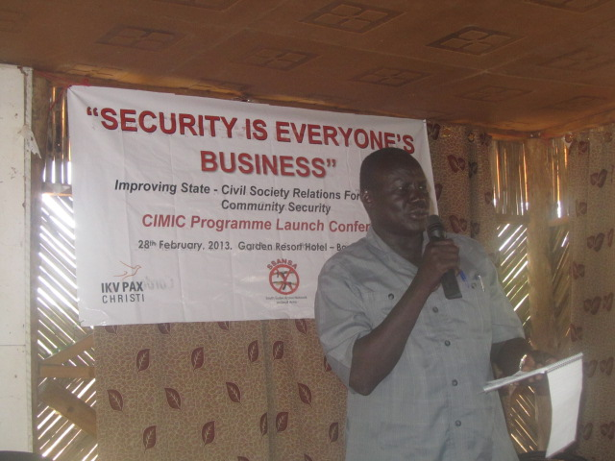
After the civil society side expressed their security concerns, state institutions were welcomed to discuss these issues and enlighten citizens about whether there are any efforts to address them. It came up that, Local government authorities by and large shared views of the civil society with regards to security challenges. They following were emerging issues from their discussions.
The commissioners held that the very slow judicial proceeding is a problem in Bor is a problem to addressing insecurity. Where communities seek quick administration of justice, proceedings take very long – leaving a heavy case log – thus, civilians end up revenging. Besides the only judicial court of the state is located in Bor – which is distanced from the people. This means, pursuit of justice is both costly and hectic for community members from the counties. Though mainly predominant in interpersonal crimes, this issue is an immense contributor to the cycles of violence among the communities.
Commissioner of Twic East County – Hon. Dau Akoi
Local authorities and security institutions felt that it was necessary for communities to have access to telephone network so that information flows easily to facilitate quick response in case of security emergencies.
Commissioners have stressed that most of the policemen/women who have been deployed in the counties are of old age and they cannot rescue the communities from dangers. This undermines government efforts to address security problems at the counties. They urged that there should be a proper process argued that there should be a process to change the composition of police at the local level.
Commissioner of Twic East – Dau Akoi
“My county has become a second battlefield. As I talk here, people are following their stolen cattle in the bushes. Some police just sit, waiting for their salaries. We need active police. Those police who can run after criminals who raid cattle.” A commissioner lamented

The government side also reported that tractors are being procured to help in boosting agriculture in the state – to begin with, some 5 counties. It was indicated that the five will be chosen from the counties most affected by violent conflicts. With the program communities would have alternative livelihood, other than relying entirely on cattle.
The designate commissioner of police for Jonglei State gratefully noted the openness of the discussions, and stated that it would have been even much useful if held before the disarmament was commenced. He informed the forum that the police will be deployed in buffer zones identified with the communities. He however, stressed that what would still limit their operations is transport, owed to the lack of proper roads in most parts of the state.
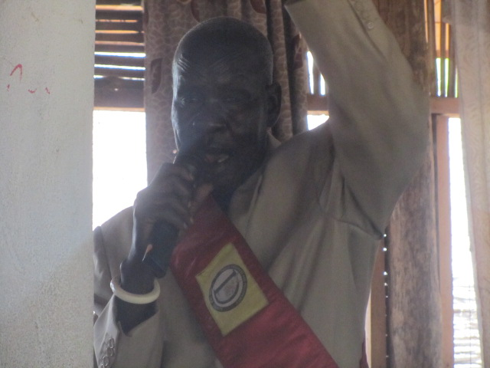
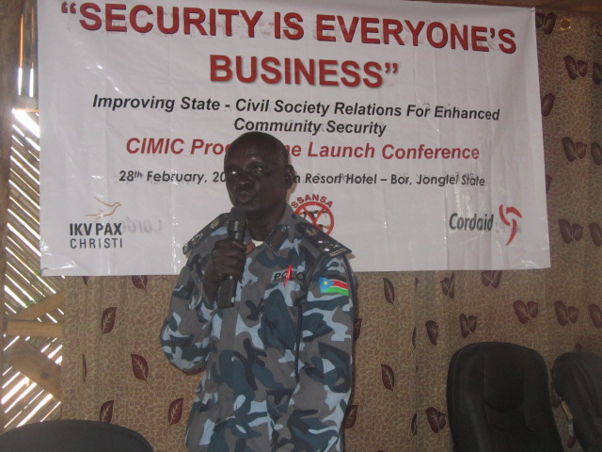
The UNMISS was given an opportunity to brief participants of their role in civilian protection – including the scope, mainly so that civilians would not expect more than what the mission could actually provide. The UNMISS representative present in the meeting declined to brief the forum saying that he does not have the mandate to speak on behalf of the mission in the meeting – but rather to just attend.
Paramount Chief of Duk County – Chuei

Acting Police Commissioner for Jonglei State - Brig. Kuer Thon
Recommendations:
- Government should embark on improving the road system so that the state capital is connected to all the counties. Participants felt that this would enhance community security in that; it can facilitate quick response of the organized forces.

- The participants have embraced the idea of the state government regarding instituting community police at Bomas levels to fill the community security gaps created by arms removal. Participants felt that this idea would work out if implemented well. However, they cautioned that number of community police to be deployed should be balanced well with the levels of threats across the various counties. Lack of a proper balance may end up raising youth militias which the local authorities cannot control.

- Participants have stressed that government at all levels should protect the disarmed civilians who are under serious and current threats from both youth who evaded disarmament and fighters loyal to David Yau Yau – and they should continue disarmament activities to ensure that all communities are properly disarmed.
- Participants underscored the correlation between development and security and that priorities for development in the state should be directed to the areas where most sources of insecurity exist. For instance, connecting Pibor county and other counties with good roads could contribute to minimize accidents from frequent happening.
- Civil Society urged government the government, UN agencies and international organizations to help Jonglei state by constructing more water points for pastoralists and their cattle. They felt that this would reduce clashes between and among the communities at the limited water points that currently exists.
- Participants expressed their conviction that such meetings are appropriate programs to be conducted at the county levels to enable gathering information from wider coverage.
- Commissioners stressed that security needs to be taken to the people. They need well equipped patrol posts to be established at county borders to facilitate quick response.

The emerging issues together with a summary of the recommendations were read to the forum at the closing session when the governor was present. Together with the Minister of Local Government, they responded to the concerns raised during the forum. Among their responses were the following;
The government representatives stressed that let the communities help themselves at times they are well positioned to do so. They asked to citizens that while the Army will be fighting Yau Yau, the people should help fight cattle rustling. The minister indicated that the government can introduce cattle taxes to pay those who will protect the cattle from among your communities. He further indicated that it was wrong to keep unproductive old police in the police system.

“Old men in the police should be removed from the police. Police are there to protect. These old men cannot protect, so why do we keep them on salary and on service.” Minister of Local Government

The government side informed the civil society side that the government is stepping up efforts to address the isse of Yau Yau. Their concern will soon come to pass since the government is determined to end the hostilities through military confrontation.
The SPLA is moving towards Yau Yau, I asure you the government has taken seriously the issue of Yau Yau. And soon Yau Yau will seize to cause insecurity. Said the Governor
The governor acknowledged that poor road system is greatly undermining security in the state. He however, indicated that while the government recognizes it as a priority, it requires money to embark on improvement of roads. So it will be gradual process and not what the government can fix immediately.
The governor accepted that disarmament was done in all the counties but not fully done. He told the forum that, without the cooperation of communities, disarmament cannot be complete. He informed the forum that it was not the fault of the government but if the communities refused to hand in weapons, it the government cannot forcefully recover all weapons. Hi office is aware that cattle raiding are going on and almost every community is saying that their neighbors have not been disarmed. But disarmament has not stopped. And that the police is being prepared to fill the gap when the army later withdraws.
Conclusions
The deliberation was more open than initially expected because the meeting was the first test. Civil society members seemed totally not intimidated by the security sector and the state government representatives. This is a desirable setting because the forum seeks to make possible for participants – who are from various levels of authority – to freely discuss in an open and neutral ground.
There was an emotional appeal to the government to address the devastations caused by David Yau Yau. This issue seems to be a very huge concern for communities, which can lead the communities to mobilize and rearm to try protecting their communities.
There was a notable sense of feeling that it was mainly Pibor town which did not undergo proper disarmament. The claim was that the arms wielding youth fled to join fighters loyal to rebel leader David Yau Yau.
Due to the devastations caused by attacks against disarmed members of communities mainly inform of cattle raids – which often involve killing of cattle owners –emerged as a critical community security concern. If protection is not provided by government, this vulnerability factor can be a strong drive-factor for rearmament among the communities who have indeed handed in their weapons in the disarmament campaign.
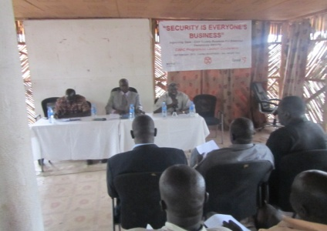
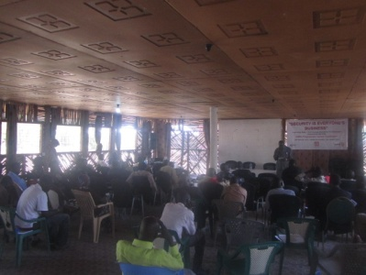
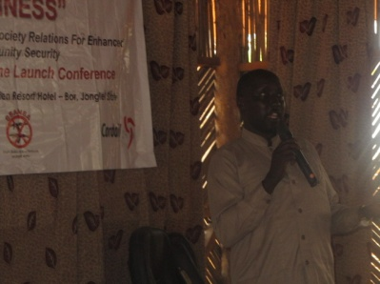
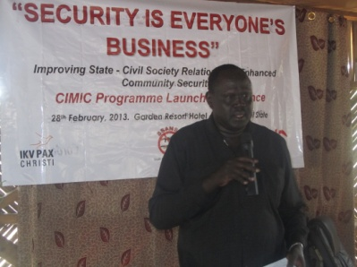
Overall, the participants embraced the idea of discussing security concerns that matters to them in a joint forum. There were several mentions of the need to roll the initiative to the county levels. This remains a follow up issue for the organizers and supporters of the conference.

South Sudan Action Network on Small Arms [SSANSA]
Atlabara C, 11th Street, West Tambura Rd | Juba, South Sudan
Tel: +211 (0) 921 362 254 | E-mail: ssansasec@gmail.com | Web: www.ssansa.org

